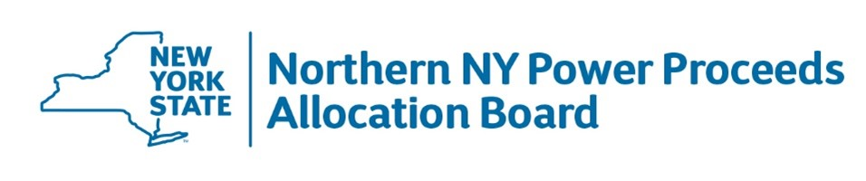

PRELIMINARY PROJECT INFORMATION WORKSHEET

Adopted January 25, 2017

INSTRUCTIONS

- Prospective applicants for Fund Benefits should complete this Preliminary Project Information Worksheet (“Worksheet”) unless invited to file a full Application for Northern New York Economic Development Benefits (“Application”). The Worksheet is intended to support the application process and enable staff for the Northern New York Power Proceeds Allocation Board (“NNYPPAB”) and the New York Power Authority (“NYPA”) to (i) provide guidance to prospective applicants concerning the application process and the Northern New York Power Proceeds Allocation Act (“Act”), and (ii) avoid the unnecessary expenditure of time and other resources.

- The submission of the Worksheet does not eliminate the need to file a full Application, and no formal decisions will be made by the NNYPPAB or NYPA on the basis of this Work Sheet.

- Prospective applicants are encouraged to review the document “Board Procedures, and Board Policies Relating to Review of Applications for Fund Benefits” to understand the program, including eligible applicants and eligible projects, before completing this Worksheet.

- NNYPPAB and NNYPPAB staff reserve the right to request additional information relating to any proposed project discussed in the Worksheet before or after the filing of a formal application for Fund Benefits.

- Questions relating to the completion and submission of the Worksheet should be directed to: NNYPPAB Staff at 315-764-6603, 315-412-4991 or Patricia.Wilson@nypa.gov

The undersigned solemnly affirms that to the best of my knowledge, information and belief, the Preliminary Project Information Worksheet is complete and that all statements, including all schedules, attachments and additional information submitted in connection herewith, are true and accurate at the time this document is submitted.

Signature
Type Name
Title |  | Date (mm/dd/YY)
Relationship to prospective applicant
Submission date:

Applicant and Project Information
Project name:
Project location/address:
Complete legal name of applicant:
Applicant address:
If applicant operates through a DBA, list DBA name:
Applicant contact name:
Applicant contact address:
Applicant contact phone(s):
Applicant email address(es):
Applicant’s legal form/status: | “C” Corp:
 | “S” Corp:
 | LLC:
 | LP:
 | Sole Proprietorship:
Publicly Held For
Profit Business:
 | 501(c)(3):
 | 501(c)(4):
 | 501(c)(6):
 | Other: | please describe:
State law under which applicant is formed and exists:
Is applicant a public/government entity, or was it formed by such an entity? If so, please describe:
Project Information
Total project cost:
Amount of assistance requested:
Projected start date:
Projected completion date:
Does applicant own the project site?
Will the applicant own the project upon completion?
Will the applicant operate the project?
Is the project subject to legal or regulatory approvals, determinations, or process that must be completed before it may progress? If so, list all:

Has the applicant or any other person applied for Fund Benefits for any part of this project, or a related project? If so, describe the project and the status of that application:
Please provide a brief project description:
500 Character Limit
How would applicant use an award of Fund Benefits? Please be specific, and complete the project budget of sources and uses below.
500 Character Limit
Project Budget
Outline the total costs for the project in which you are seeking funding. Total sources must equal total uses, based on best information known.
Uses/Expenses |  | Explanation (if applicable) |  | Cost | Terms
Salaries & Wages |  |  |  | $
Rent/Lease |  |  |  | $
Supplies/Materials |  |  |  | $
Training |  |  |  | $
Planning/feasibility study cost (specify) |  |  |  | $
Land acquisition |  |  |  | $
Acquisition of existing assets (specify) |  |  |  | $
Demolition |  |  |  | $
Environmental remediation |  |  |  | $
Hard costs, inc. contingency |  |  |  | $
Infrastructure costs (specify) |  |  |  | $
Machinery & Equipment (specify) |  |  |  | $
Furniture, fixtures, equipment (specify) |  |  |  | $
Soft costs, inc. contingency |  |  |  | $
Developer fee |  |  |  | $
Other (specify) |  |  |  | $
Uses/Expenses Total: |  |  |  | $ | Must equal sources.
Sources/Financing | Provider |  |  | Amount | Terms
Subject Request for Fund Benefits |  |  |  | $
Senior Debt |  |  |  | $
Subordinate Debt |  |  |  | $
Total Other Sources: Committed (provide specifics, below) |  |  |  | $
Total Other Sources: Potential (provide specifics, below) |  |  |  | $
Corporate Cash/Line of Credit/Related Entity Loan |  |  |  | $
Additional Cash Equity Contribution |  |  |  | $
Deferred developer fee |  |  |  | $
Other (specify) |  |  |  | $
Unidentified |  |  |  | $
Other Sources: Committed
Provider | Use of Funds |  |  |  | Terms
 |  |  |  | $
 |  |  |  | $
 |  |  |  | $
 |  |  |  | $
Other Sources Committed Total: |  |  |  | $
Other Sources: Potential
Provider | Use of Funds & Request Status |  |  |  | Terms
 |  |  |  | $
 |  |  |  | $
 |  |  |  | $
Other Sources Potential Total: |  |  |  | $
Allowance for rejection of funding requests from potential sources (to show balanced budget) |  |  |  | $
Sources/Financing Total: |  |  |  | $ | Must equal uses.
Provide copies of Commitment Letters or Term Sheets for the sources listed above, if available.

Economic Impact
- Does any portion of this project include retail, residential, entertainment or places of overnight accommodation? If so, please explain which of these is included in your project and what percentage of your total project cost is going to this project element. | No Yes, please explain: 500 Character Limit
- Will this project support the growth of business in the state and thereby lead to the creation or maintenance of jobs and tax revenues for state and local governments? | No Yes, please provide detailed explanation: 500 Character Limit
- Will this project have a measurable impact on regional tourism? | No Yes, please explain: 500 Character Limit
- Will this project have a measurable impact on the regional agriculture industry? | No Yes, please explain: 500 Character Limit
- Will this project train under-represented communities for specific job placement? | No Yes, please explain: 500 Character Limit
- Will this project attract new investment or otherwise impact business investment in the area? | No Yes, please explain: 500 Character Limit
- Will this project create entrepreneurial opportunities with a measurable increased potential for successful outcomes? | No Yes, please explain: 500 Character Limit
- Does this project create/expand clean energy sources or create/expand energy efficiencies? | No Yes, please explain: 500 Character Limit

